Oakland International Academy
December 2020

Information Update!
The school has developed an E-mail which parents and guardians are welcome to email with questions about how to keep safe and healthy during this time physically and mentally. You are also welcome to email asking questions about services in the community if your household needs any extra support. These services are in the Hamtramck area. The email is confidential and is sent to the school social worker. You are welcomed to ask questions anytime with the email below and you will get a rapid response.
Email Address: oiaparenthelphotline@emanschools.net
Tamara Ward, MSW, LLBSW, RSST
School Social Worker

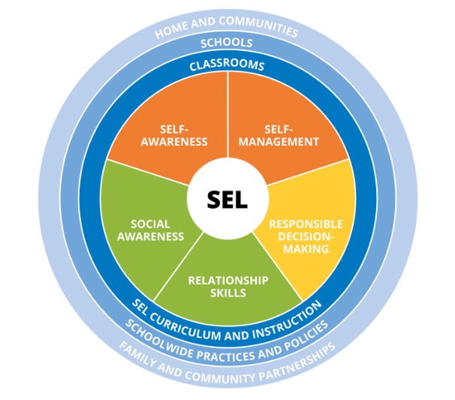

Social and Emotional Learning at home and in school
Starting in December, I will be coming into every class and having a virtual social and emotional learning activity with them at a minimum once a month. We will cover different topics for different age groups and try to have fun even though we are online.

